

**USER MANUAL**

**Title:** IT FeedBack

**Group:** CS2304B

|  |  |
| --- | --- |
| **NAME** | **MATRIC NO.** |
| MUHAMMAD NA'IM BIN RIZALI |  |
| MUHAMMAD AQQMAR BIN ZULKARNAIN |  |
| MUHAMMAD EMIR HAKIM BIN MOHD FAHIMI |  |
| MOHD NAZZIM BIN LAHAJI |  |

**Prepared For:**

DR. MARSHIMA ROSLI

**1.0: Staff Page**

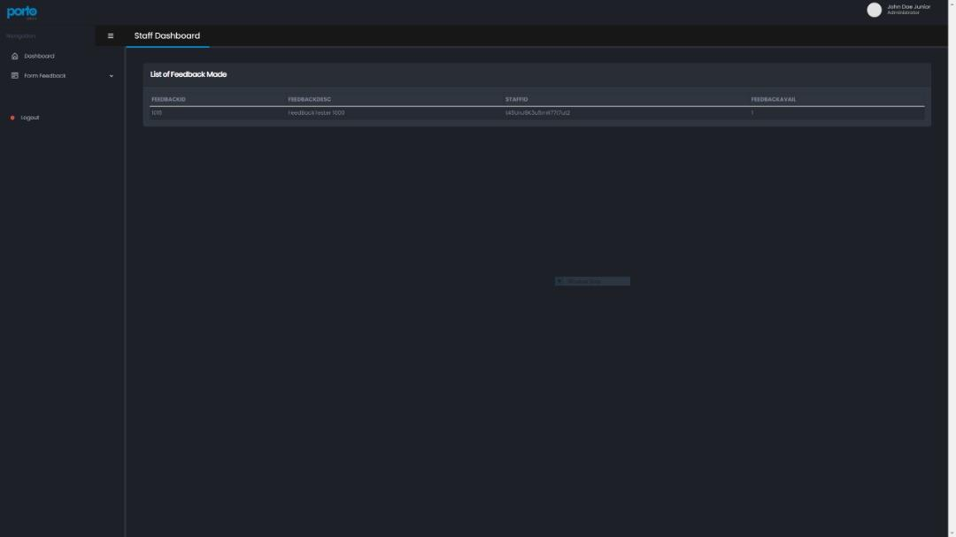

*Figure 1.1: Staff dashboard*

Based on the figure 1.1. After the user(staff) has successfully logged in. The web will redirect to the staff dashboard screen which will display which feedback is currently set on ‘available’.

**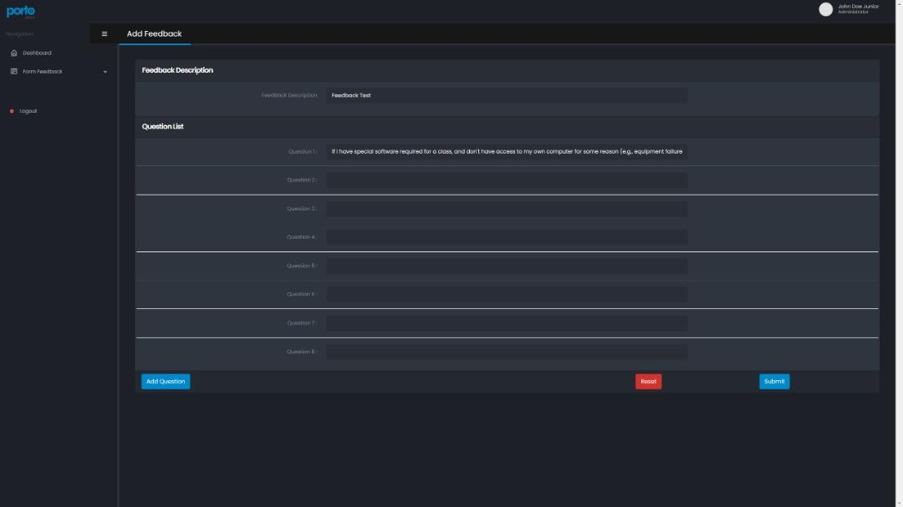***Figure 1.2: Add Feedback Form*

Based on figure 1.2. The add feedback form allows the user to add new feedback and questions. Steps to add feedback:

1. Click the add feedback form in the navigation bar on the left.
2. User must input a new feedback description.
3. User must input at least 1 question regarding the feedback.
4. Click the ‘add question’ button to input more questions.
5. Click the submit button to store the feedback.

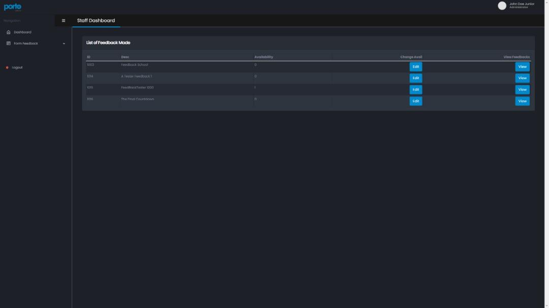

*Figure 1.3: View Feedback*

Based on the figure 1.3. The view feedback page will display feedbacks from the database and user can choose either to edit the feedback or to view feedback answers from students.

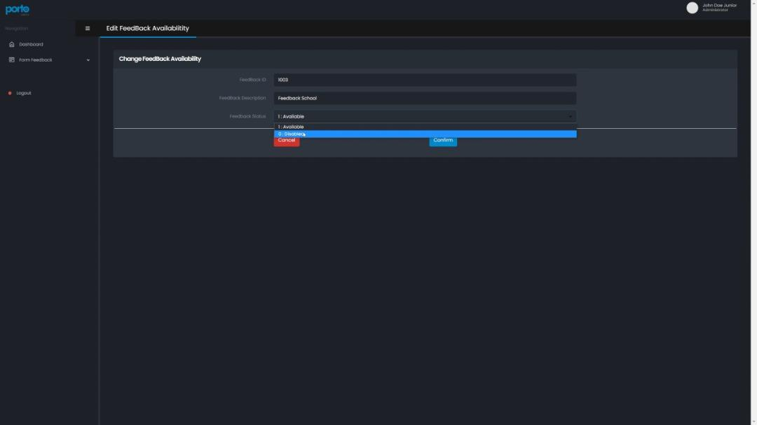

*Figure 1.4 Edit Feedback*

Based on figure 1.4. The edit feedback page will be shown when the user clicks the ‘edit’ button from the view feedback page. In this page user can set the availability of the feedback which the students will be prompted to answer.

Steps to edit availability:

1. Click the view feedback button from the navigation bar on the left.
2. Click edit on the chosen feedback.
3. Choose the availability option from the drop down menu.

*Note : Only **ONE** feedback can be set to “Available” at a time.

1. If however the “User” wants to allow his/her feedback, they must consult with the particular “User” to change their feedback from Available (1) to Disabled (0).

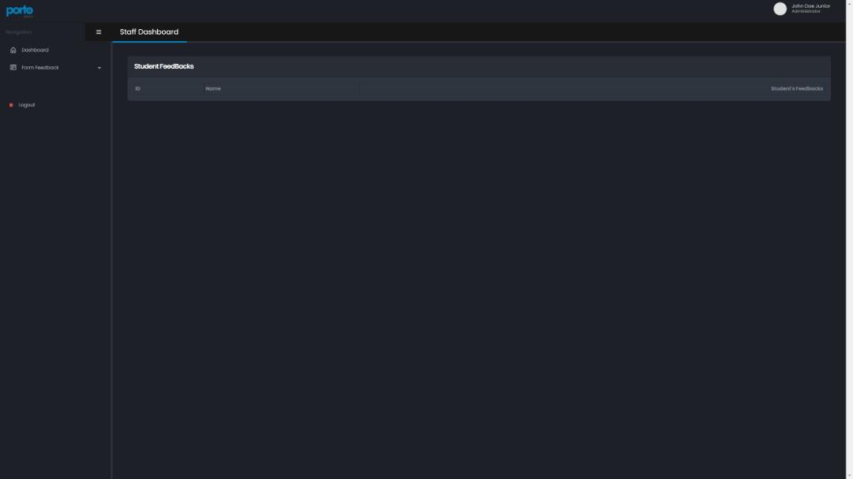

*Figure 1.5: Student Feedback*

Figure 1.5 will display students' names and id who have given their feedback based on a particular feedback chosen to be viewed. User can view their answers by clicking the view button.

**2.0: Student Pages**

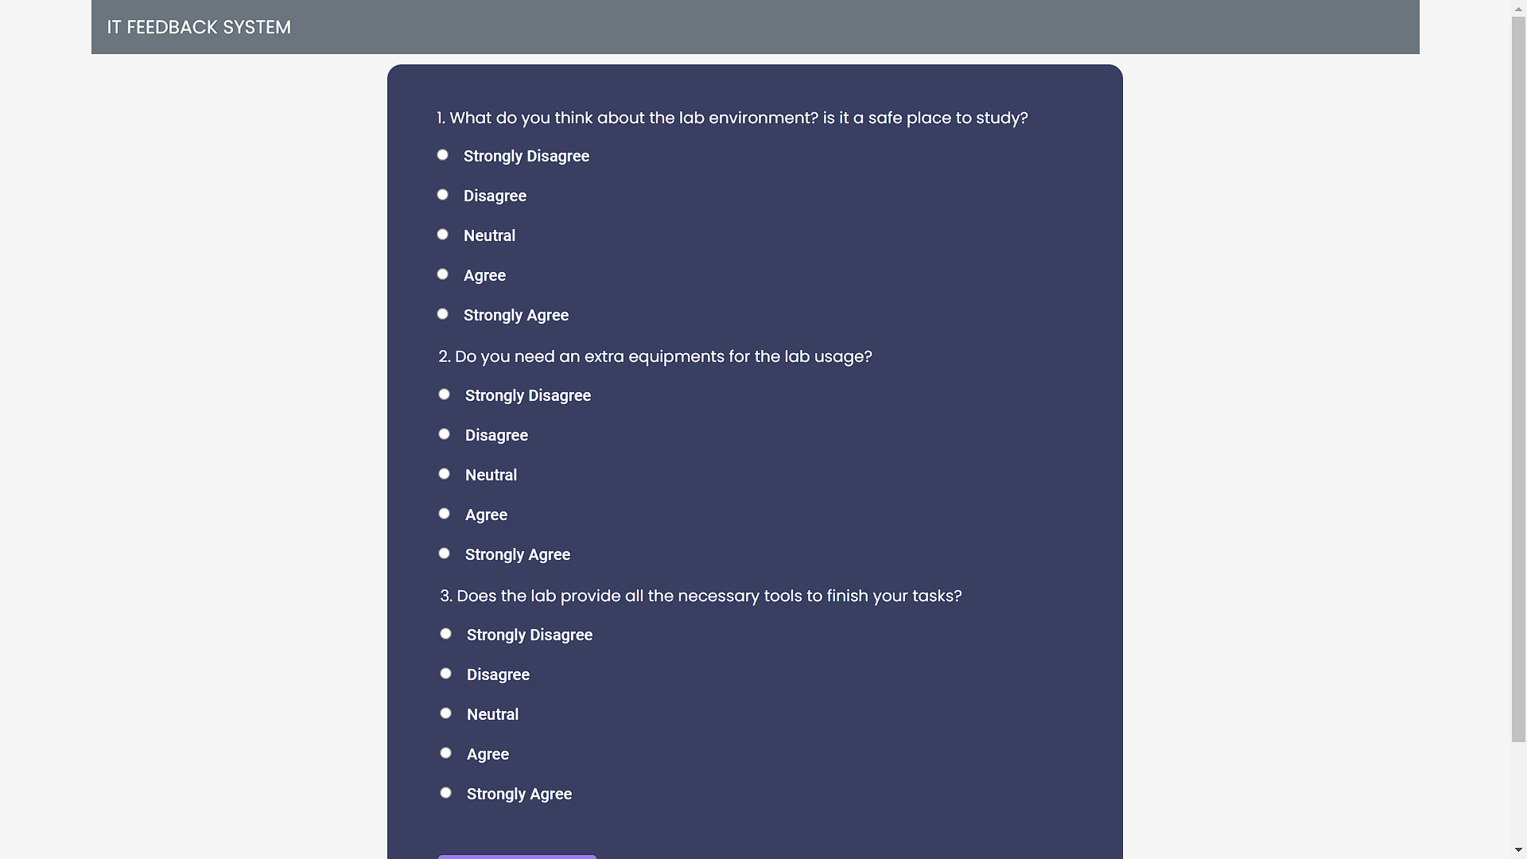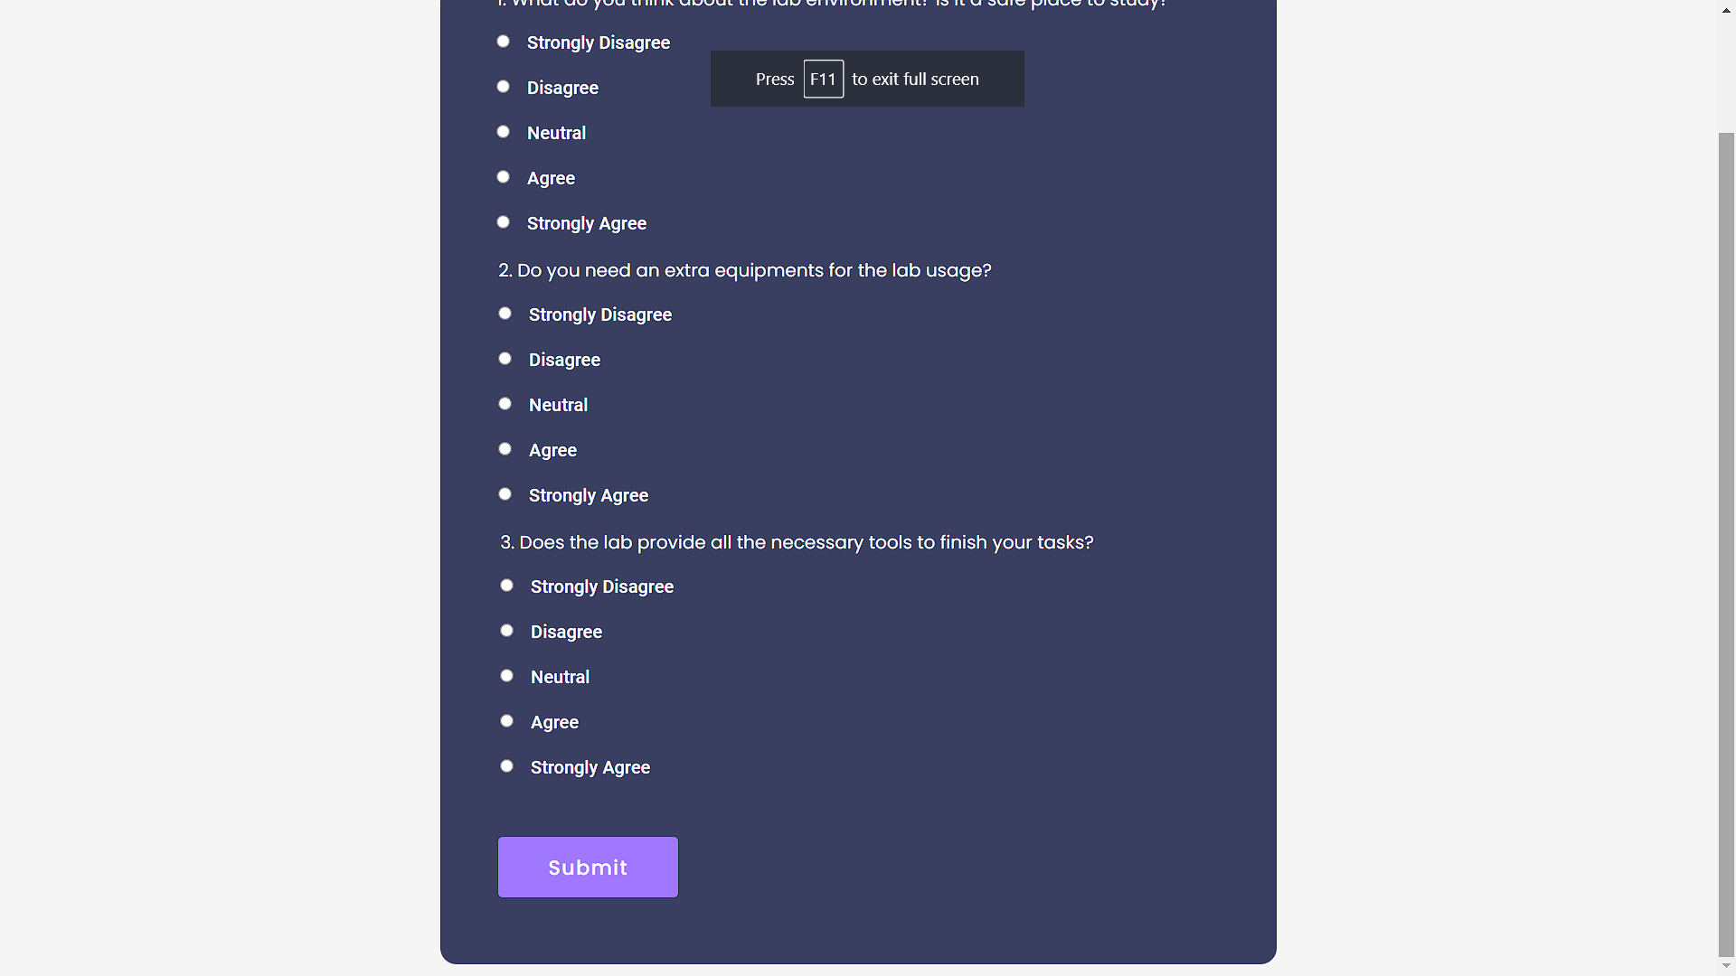

*Figure 2.1: FeedBackScreen.jsp*

Based on figure 2.1, if the user has not yet answered the feedback, the question taken from the database will be displayed and all the input radio buttons are required for each question. After the student has answered all the questions, they are required to submit the answer. After the student has submitted, they will be redirected into other pages.

In other cases, when there’s no feedback (Feedback Avail = 0) in the Database, the student will have an option to opt out from the system.

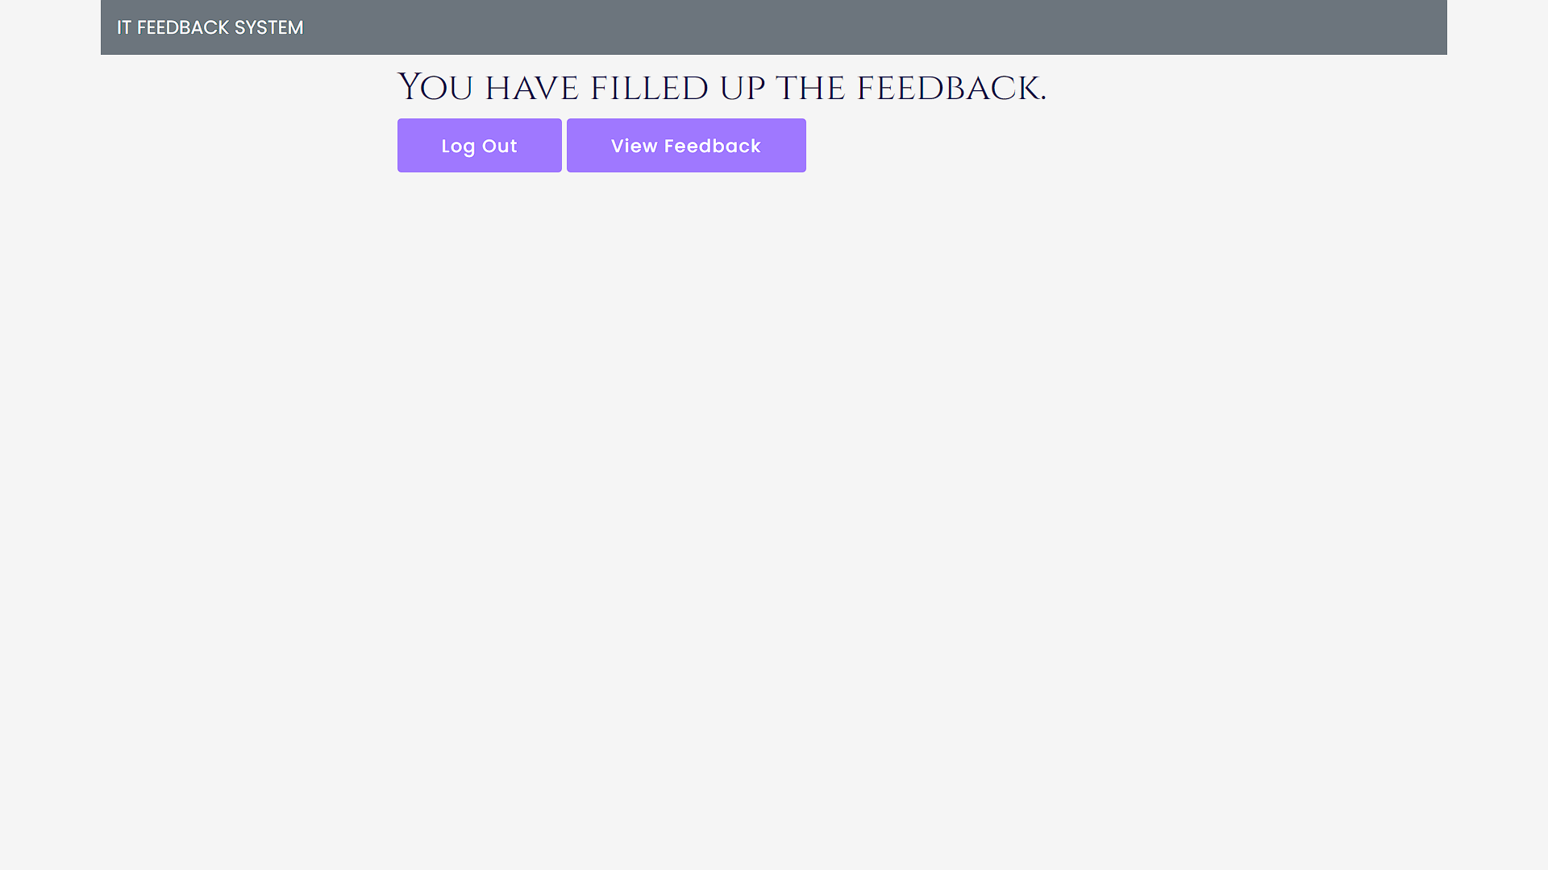

*Figure 2.2: FeedBackScreen.jsp (Another)*

Based on figure 2.2, student id from the session, if the student has already answered the feedback it will display "You have filled up the feedback" along with the log out and view Feedback button. Students can view their answer by pressing the “view Feedback” button and will redirect to viewStudentAnswer.jsp.

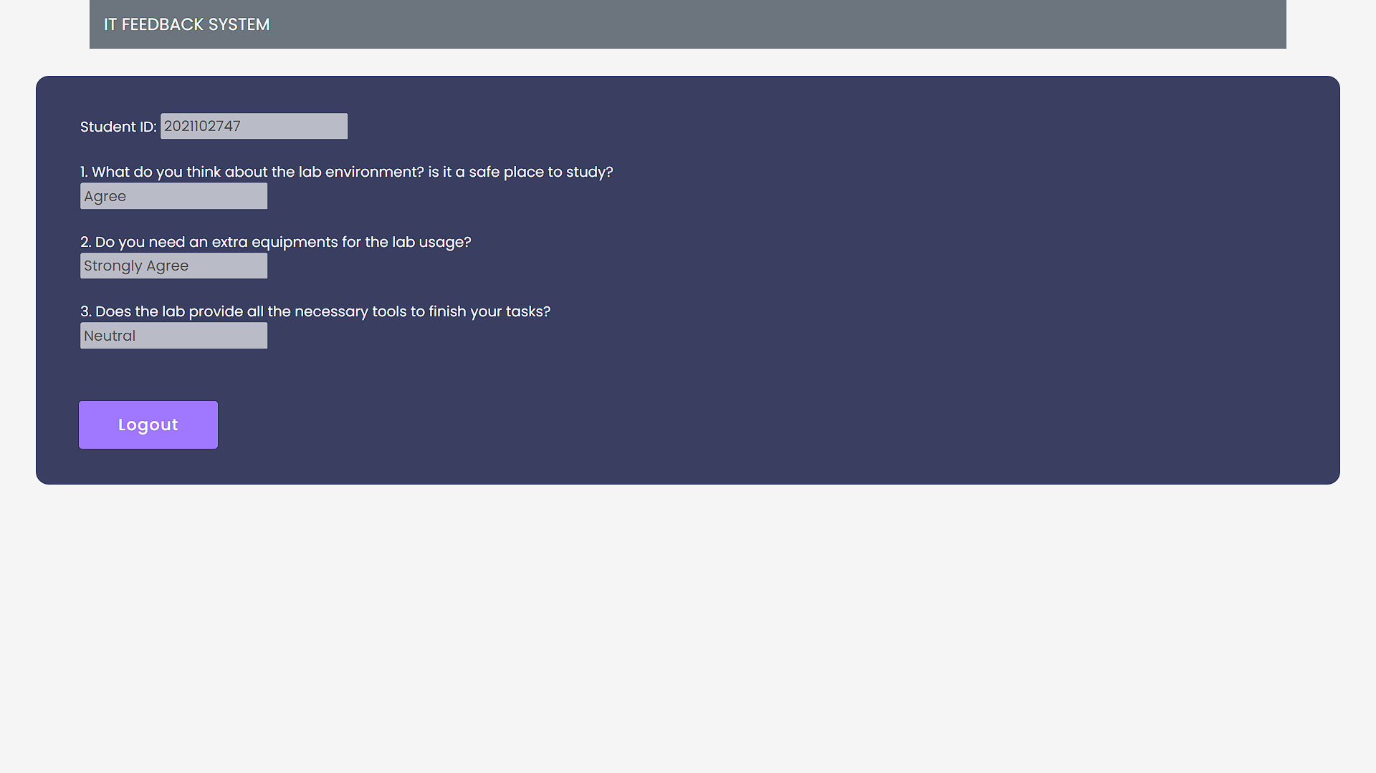

*Figure 2.3: viewStudentAnswer.jsp*

Based on figure 2.3, viewStudentAnswer.jsp will display the answer and question from table studentAnswer in the database based on current student id in the session. The logout button will redirect to the login screen and end the session.

**3.0: Login Page**



*Figure 3.1: Login.jsp*

Based on figure 2.1, students will login using their username and password. Then, press the “Log In” button to enter into next pages. If the students log in with the wrong username or password, the pages will show error messages.

Register Button (Acceptable Project Requirement) will direct ‘User’ towards a registration page.

**4.0 Register Page**

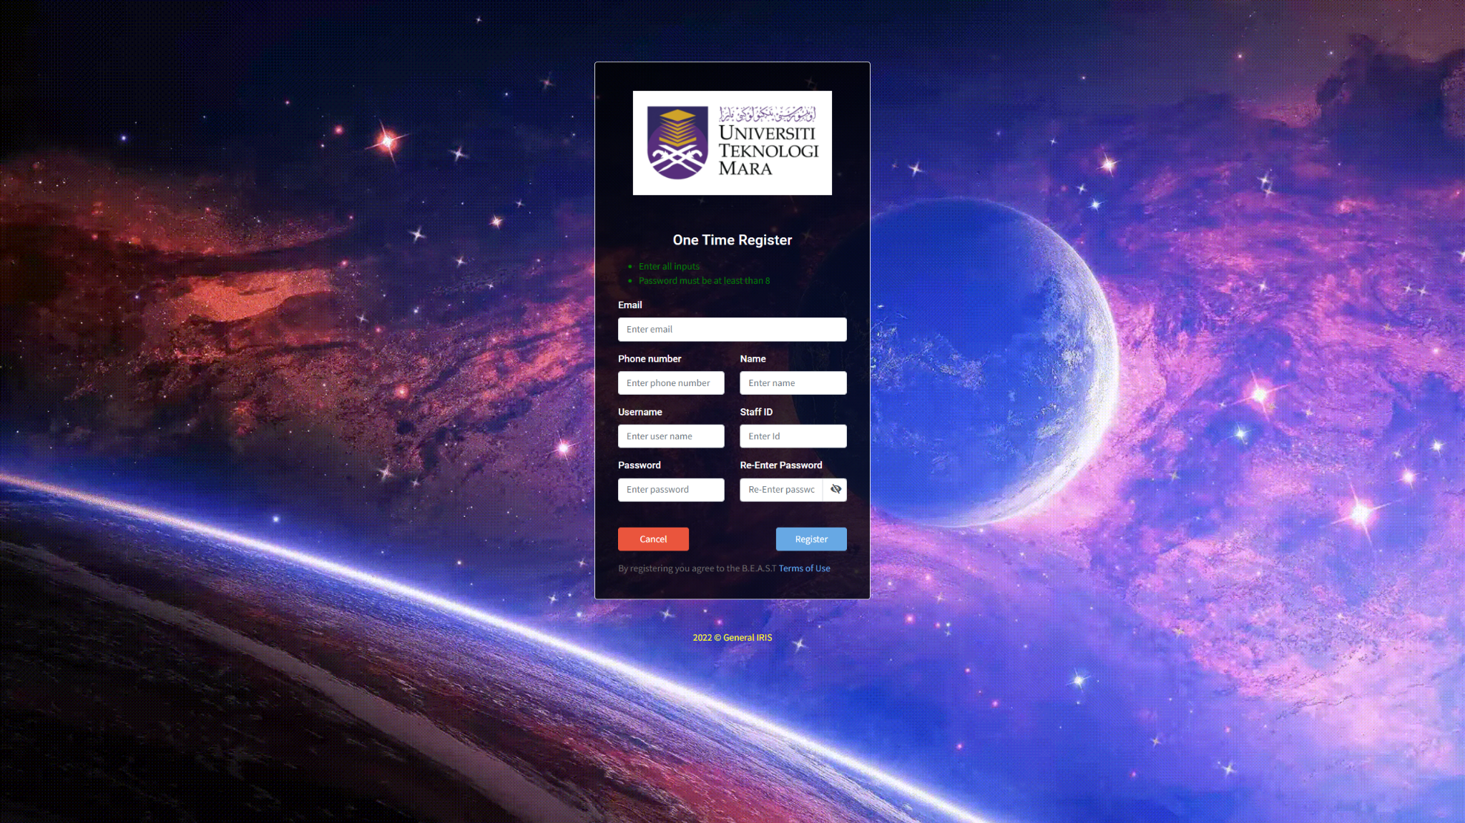

*Figure 4.0: Register.jsp*

Based on figure 4.0, new staff are allowed to register as a new user to access the system. This functionality however is **for the purpose of the project requirements** as allowing staff to register on different sites is not the best practice especially for a login where both student and staff use to access the system.

In other cases, if an existing staff tries to register once more with their staffID it will end the registration process. Keep in mind, all input are required to be inserted to complete the process.